
Smart road




Smart road

Hend A. Ahmed, Mariam M. Mostufa, Salma E. Mohamed.
Gharbiya STEM High School
G12 Capstone leader: Mrs. Nardine fayek
General Capstone Leader: Mrs. Hala Hassan
December ,7, 2025

Content
ــــــــــــــــــــــــــــــــــــــــــــــــــــــــــــــــــــــــــــــــــــــــــ
Introduction……………………………………………
I. Present and Justify a Problem and Solution Requirements
1.1 Egypt Grand Challenges……………………………………………….
1.2 Problem to be solved……………………………………………….
1.3 Research……………………………………………………………………
1.4 Prior solution……………………………………………………………
II. Generating and Defending a Solution
2.1 Solution and design requirements………………………………
2.2 Selection of solution…………………………………………
2.3 Selection of prototype………………………………..........................
III. Constructing and Testing a Prototype
3.1 Materials and Methods…………………………………………………
3.2 Safety precautions…………………………………………….
3.3 Test Plan ………………………………………………………………
3.4 Data Collection………………………………………………………
IV. Evaluation, Reflection, Recommendations
4.1 Analysis and discussion………………………………………………
4.2 Recommendation……………………………………………………
4.3 Learning outcomes………………………………………………………
4.4 References………………………………………………………………
Chapter 1 (Present and Justify a Problem and Solution Requirements):

Egypt Grand Challenge
1- Deal with urban congestion and its consequences :
Urban congestion is a serious problem in Egypt with large and negative effects on the quality of life as the time wasted standing still in traffic results in unnecessary fuel consumption, causes additional wear on vehicles and increases harmful emissions as well as having negative effects on people’s health.
Urban congestion appears at traffic congestion, its haves many causes fuel subsidies result in cheap petrol and diesel, which in turn result in more private cars on the streets and also the lack of parking areas results in cars having to turn back so that causes increase in the amount of time taken so that leads to excessive fuel consumption so that causes more air pollution also raise the number of accidents.
(Emam Hammad, 2023)https://www.semanticscholar.org/paper/Application-of-planning-standards-for-land-uses-of-Hammad/15fc1863d74951df90e77bd2e99c2a74fdb7ff70
Specifically, Cairo, contains more than one-fifth of Egypt's population. Cairo also an important contributor to the Egyptian economy in terms of Gross Domestic Product and jobs, Traffic congestion is a serious problem in Cairo with large and adverse effects on both the quality of life and the economy like the time wasted standing still in traffic, time that could be put to more productive uses, all the negative effects have very real and large monetary and nonmonetary costs not only for the economy of Cairo but given its size, for the economy of all of Egypt.
( Abdelati , 2025)https://jisse.journals.ekb.eg/article_410946_8bfe889e7f4c6ace102c7eb69f3def28.pdf
There are solutions that can be implemented to reduce the urban and traffic congestion:
- Improving traffic management and the use of traffic lights at intersections.
- Managing parking spaces, building parking structures would also be very effective.
- Building sidewalks and road crossings providing space for pedestrians’ circulation that minimize accidents and reduce traffic disruptions.
- Regulation of vehicles and drivers that improves traffic flows.
- creating taxi and buses stops and organizing the routes that better serve the travel needs of the public.
- ( Faheem ، El Shorbagy ، و Gabr، 2024) https://mej.researchcommons.org/cgi/viewcontent.cgi?article=3191&context=home
Problem to be solved
Urban congestion is a big challenge faces Egypt specially at Cairo as it contains more than 19 million inhabitants, it is to more than one-fifth of Egypt’s population. Cairo is also an important to the Egyptian economy in terms of GDP (Gross Domestic Product) and jobs. The population of it is expected to further increase to 24 million by 2027, and correspondingly its importance to the economy will also increase.
As urban congestion shapes are the traffic congestion.
Traffic congestion is a serious problem in Cairo with large and adverse effects on both the quality of life and the economy. The growth of number of vehicles on the Egyptians roads many vehicles a month so that increase the traffic congestion and the impacts and negative effects.
From the reasons of it traffic design as A good traffic design reduces the travel distance, the total journey time, fuel consumption, and exhaust emissions, etc. and a bad traffic design creates traffic congestions which result in more aggressive
driving, and negatively affects the fuel economy, air pollution, and the total vehicle
performance.
As general it a big problem faces Egypt and need to try to solve.
( Abdelati ، 2025)https://jisse.journals.ekb.eg/article_410946_8bfe889e7f4c6ace102c7eb69f3def28.pdf
If the problem solved:
- decrease time waste and save the time for important things as the vehicles will not stay a long time at the traffic congestion.
- reduce air pollution when vehicles transfer faster it will reduce fuel consumption.
- Protect human health as reduce the emissions of vehicles produces from it.
- Improve the quality if the live from different sides.
- Enhance economic productivity.
- Better traffic flow in central areas and everywhere has a traffic congestion.
If the problem not solved:
- Increasing the accident rates.
- Affecting the economy due to increasing the rate of fuel consumption and vehicle maintenance and also shipping cost.
- Increases the air pollution as producing more fuel emissions and more time doing it.
- Wasting time as standing at traffic congestions long time as you could benefits from that.
- Effects on the mental health of the drivers as Increasing aggressive driving which leads to frustration and stress.
- Decreases in the economy as the fuel consumptions causes additional wear and tear on vehicles.
( Faheem ، El Shorbagy ، و Gabr، 2024)https://mej.researchcommons.org/home/vol49/iss2/18/

Research
Topics related to the problem
Look at urban congestion
Urban congestion refers to what happens when many vehicles, people, or data packets use or try to use the same infrastructure at the same time over its capacity.
Types of urban congestion:
- Vehicular Traffic Congestion: This is the most common. This appears when cars stop or slow down, especially in rush hours or in crowded intersections, construction areas, and this wastes fuel, time, and increases pollution.
- Public Transport Congestion; that is shown in the crowding of buses, trains, and metros, also in rush hours, which causes passenger discomfort, delays, and reflects low-quality service of cities.
- Pedestrian Congestion: that forms in crowded urban regions, such as sidewalks, especially near transportation centers and important events. That makes the motion of pedestrians slow and affects smooth transportation in the city.
- Data Network Congestion:
Hidden congestion but important in smart cities. That occurs when data networks are overloaded, which may cause slower internet speeds, communication, and buffering issues that depend on the speed of communication.
The impact of urban congestion on the environment, economy, society, and Urban Planning.
1-economic impacts:
Congestion causes waste time, delays in public transport, increases fuel consumption, and higher logistics costs for businesses. It also makes the cities less attractive for investment.
2-social impacts:
Congestion causes a reduction in life quality by increasing stress and pressure, delaying communication, reducing opportunities and services, especially those that depend on transportation systems.
3- Environmental Impacts:
Increasing air pollution by the emissions of cars when they stop, greenhouse gases, and health issues like respiratory problems.
4-Urban Planning and Spatial Impacts:
Random urban sprawl outer of cities, depending on private cars, and increasing the cost of developing infrastructure. (Sustainability Directory, 2025) (Sustainability Directory, 2025)https://pollution.sustainability-directory.com/term/urban-congestion/
The study found that the busiest corridors and intersections are the ones without traffic signals and unplanned U-turn spots. The behavior and culture of road users were the main causes of delays, accounting for 24% of the total. Engineering and traffic management issues were next, each accounting for 20%. After that came issues with public transportation and rules, and finally issues with pedestrian and bicycle paths. ( Alsobky, Shawky, El-Dabaa , Hasan, & Sharaf, 2023)https://arabsti.journals.ekb.eg/article_337918.html?lang=en
Sensor calibration and precision techniques
Sensors can drift or show errors as a result of changes in the environment, manufacturing standards, or continuous use. Sensor calibration is an essential procedure to ensure reliable and precise results. For it to calibrate a sensor, its output must be compared to a known reference and modified accordingly. To allow for variations, this procedure may involve methods like linearization, scaling, or offset correction. In applications that require great reliability, frequent recalibration protects accuracy and prevents mistakes.
The kind of sensor and the needs of the application determine the precise calibration methods. For example, accurate thermostats or reference thermometers can be used to calibrate temperature sensors, although controlled vibration sets may be necessary for accelerometers. Error measurement and correction can be assisted by instruments like multimeters, oscilloscopes, and calibration rigs. Real-time changes are made possible by advanced methods, including algorithmic machine learning and software-based repairs.
(Earl, 2024)https://cdn-learn.adafruit.com/downloads/pdf/calibrating-sensors.pdf
Topics related to the solution:
In order to effectively manage traffic across city roadways, an advanced traffic management system (TMS) is a context-aware solution that uses analytics to predict and collect real-time data from linked road infrastructure. Such traffic control software serves as a base for the setup of an intelligent transportation management system when combined with wireless urban networking. ( Sakr , team , & El-Afifi, Intelligent Traffic Management Systems:, 2023) ( Sakr, team, & El-Afifi, 2023)https://journals.ekb.eg/article_321169_eea7fa0cc95cccb6d72c2781eaa5fc6f.pdf
Sensor Technology for urban congestion
Ultrasonic Sensors:
Without coming into direct contact with an object, ultrasonic detectors may detect its presence and calculate its distance. They do this by generating and monitoring an ultrasonic echo. The effective range in air ranges from a few centimeters to multiple meters, depending on the sensor and object characteristics. An object in the sensor's field of view reflects ultrasonic pulses that the ultrasonic sensor (also known as a transducer) generated. ( Toa & Whitehead, 2021)https://www.ti.com/lit/an/slaa907d/slaa907d.pdf?ts=1761972998785&ref_url=https%253A%252F%252Fwww.google.com%252F#:~:text=variety%20of%20applications.-,1.1%20Principles%20of%20Ultrasound,of%20view%20of%20the%20sensor.
Methods of Data Analytics and Predictive Maintenance
Lack of data is not an issue for a lot of companies and governmental organizations. In actuality, the opposite is true: there often is too much evidence available to reach an accurate conclusion. There are many different components to the data analysis process. Data collection, processing, cleaning, analysis, and transmission are some of the essential elements of data processing.
There are two types of primary data collection methods: quantitative and qualitative. Quantitative approaches are typically faster and less expensive since they make use of calculations, such as closed-ended questionnaires and statistical analysis like regression and correlation. They make it possible to compare results in a uniform way. On the other hand, qualitative methods lack the use of calculations in mathematics and instead focus on non-numerical components like words and feelings.
There are five main categories of data analysis techniques:
1. Text analysis, also known as data mining, finds patterns in huge databases to transform unprocessed data into insightful findings.
2. Descriptive analysis, which describes data, and inference analysis, which makes inferences from samples, are two types of statistical analysis that concentrate on past events.
3-To try to solve problems based on previous information, diagnostic analysis examines the reasons behind patterns in the data.
4. Predictive analysis uses historical data to predict future events, depending on the historical context and quality of the data.
5. Prescriptive Analysis: This technique integrates knowledge from previous methods to suggest practical business options.
(Islam, 2020)https://www.researchgate.net/publication/338528149_Data_Analysis_Types_Process_Methods_Techniques_and_Tools

Prior solution
- PAPER NAME: Navigating urban congestion: A Comprehensive strategy based on an efficient smart IoT wireless communication for PV powered smart traffic management system:

The urban congestion has been a widespread challenge in Egypt right now leading for higher rates of fuel consumption, and trip time, affecting directly on the increasing of road hazards, the normal systems which is not supported by IOT and AI is not capable of treating the dynamic nature of transportation, this solution proposed a multi-modal intelligence traffic management aims to transform Egypt’s urban mobility landscape and enhances traffic efficiency and safety by integrating PV power modules, incorporating battery storage, raspberry pi 3 microcontroller, integrated cameras, radio frequency identifications, and 5G communication.
The system includes many things that enhance the system as the advanced algorithms such as 1D Convolutional Neural Networks (1D-CNN) to make device to device communication to ensure that the drivers would align with the orders making connectivity and coordination which is important in managing dense urban traffic. The drivers will be connected to mobile app and cloud-based platform to access the user with real-time traffic updates, route planning, and emergency response, making this platform usable in other cities which have the same traffic issues.
However the system introduce a fantastic environment to reduce traffic congestion, the cost of deploying PV modules and moreover items to the roads will be a little bit extra for a widespread adoption especially economically constrained, in addition to the maintenance of the system would be a challenge as the system is facing all the natural disasters without any shield, in the other hand the soft system could have a potential to face cybersecurity risks as the system depend on the continuous data not a saved database on the system libraries, this heavily depending on the life-time data the system could have issues when recognizing any activity at night, bad condition weather , poor lighting, or physical obstructions. The 5G networks is limited in Egypt which could lead to sever disconnections and failure to address the challenge.
The system proposes an approach to address urban congestion through sustainable technology representing a leap toward intelligent urban mobility by combining IOT and AI, serving many cities to be safer, smarter across the world. ( Ahmed, Osman, & Amer, 2024)https://journals.plos.org/plosone/article?id=10.1371/journal.pone.0310002

- The NJSEA MASSTR Project) Meadowlands Adaptive Signal System for Traffic Reduction:
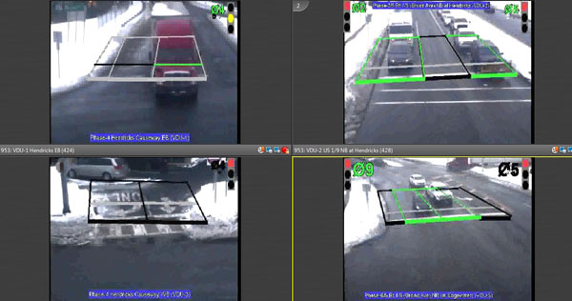
Through the use of the most recent technologies, the NJSEA MASSTR Project seeks to decrease traffic on the roads, travel-related delays, fuel consumption, and pollution in the Meadowlands region. Instead of depending on predetermined timings, it does this by using a network of 126 traffic signals that respond in real time to traffic patterns.
Figure 1
Video-based vehicle detection system
In order to improve efficiency, the NJSEA Traffic Management Center also monitors traffic operations.
The project depended on modernizing antiquated traffic control systems and combining them with an intelligent transportation system in order to achieve long-term and regional benefits.
Adaptive traffic signal control, fiber-optic and wireless communications, and vehicle detection devices are some of the main characteristics.
The installation of the system required extensive wiring, the addition of communication devices and detection cameras, and the modernization of signal cabinetry.
Pros:
- Approximately 3 million vehicles are served daily by the smart transportation system.
- The project reduces greenhouse gas emissions by more than 11,000 tons every year, vehicle delays by more than 1.2 million hours annually, and fuel consumption by more than 1.2 million gallons yearly.
Cons:
- The system requires more care and maintenance than normal traffic lights, as it depends on a single control center, advanced software, continuous camera and sensor monitoring.
- Human participation is required because to its capability to deal with severe traffic accidents and sudden road changes.
- In addition, communication failures or network outages may lead to problems or poor performance.
( International, 2024) https://njmc.s3.us-east-2.amazonaws.com/pdfs/transportation/MDTP2045.pdf

Chapter II (Generating and Defending a Solution):

Solution and Design Requirements
We work on urban congestion; our solution is works as there are a traffic and three Streets’ branching off from it. As the solution is to decreases the congestion, make the drivers go from other branch street that empty, continue them work fast and also it do better traffic flow and reduces air pollution and fuel consumption.
The project solves these problems as the system is a LEDs which put in front of each branch of the street and it glowing red when the street is full and there are an urban congestion or traffic congestion because of the traffic and it glowing green when the street is empty or have fewest cars so it manages the urban congestion and it save the time which take at standing at congestion for a long time.
The detection of the number of the cars using ultra sonic sensor as it detects if there are a something as cares so it will be multiple of them to detect all the width of the road to detect the whole road.
After that the sensors and the intelligence of the system take place as the components will be connected by ESP to take the voltage they need and send all the gathered information the results will be sent to the AI model, the AI will generate all the road maps could be selected while the journey and then the best way will be sent to all driver at a website in each, then the whole process will be reversed.
Design requirements:
- Time response: it’s the time request for the system as it works and give response from the first action to the final data time.
This calculated by timer as it from the first as the cars is detected that it is at rest to a long time than the traffic signal then the ultrasonic sensor sends this data to the ESP then to AI model then to the ESP again to take the action of lighting the LEDs to guide the drivers to the empty road and from another way at a parallel time the AI model send to the firebase to send it to the driver at a website.
All time of this steps must take less than or equal to 1 second as an ideal time response.
- System accuracy: as all the system get correctly response and transfer the date correctly.
As the first action is detection of traffic congestion then open the LEDs of the three sub streets also send a massage at the website to the driver.
So, the total responses of the system are 12 reactions, then use the law of accuracy.
$$Accuracy=\frac{system Accurate responses}{total responses} ×100\%$$
And after calculation it must be 90% for all responses is aright to solve urban congestion.
- Trip time: as it the time of trip before the system as congestion, waiting and waste time than after the system as there are no waiting and the car moves at shorter time.
To explain that more: at first the distance is direct with the time then there are three ratios $\frac{d1}{d2}=\frac{t1}{t2}=\frac{t3}{t4}$ .
D₁: the distance of the road at the large scale.
D₂: the distance of the road at the prototype.
T₁: the time of the trip at congestion at the large scale.
T₂: the time at congestion at the prototype (given by the ratio).
T₃: the time of the system at large scale.
T₄: the time of the trip by the system at the prototype.
Then the trip time reduced percentage is
$\frac{time before the systym-time after the system}{time at congestion}×100=\frac{t1 - t3}{t1}×100$.
And this ratio must be approximating 70% or more.
Selection of Solution
The main Egyptian grand challenge that the project concentrated on is urban congestion; to address this challenge the project has been chosen to solve a certain problem in Saeed Street intersection with el moheb street by a system to distribute the cars before make crowding inside the street.
The prototype is divided into two main pieces, the main street which is the first 55 meters from el moheb Street (the traffic signal) and the other part is the other sub streets (three sub street), the first piece contains two Ultrasonic sensor hanged on a tall column to calculate the number of cars between both end points of the interval as there’s a one in the beginning of the streets U₁ (next to the traffic signal) and another one in the ending of the interval U₂ (next to the beginning of the first sub heading) the number of cars is calculated by this equation U₂-U₁ = N.O of cars in the interval.
The second piece is containing the other sub streets that the cars would pass by when the main piece is facing crowding, each street is containing Ultrasonic to make sure that the street is not facing any problem inside it, all of the streets would have additional method to announce the driver at any time his phone is closed or out of connection if the street where crowded or not as there’re LEDs showing the state of the street by colour (red for crowded and green for not crowded).
the main work will happen by certain order to do things like that: -
- The cars inside the interval of the main street are making a variable and the variable value is defining the way that the system would send the messages to all cars that their road map is passing by the street.
- The system calculates by simple ratio the number of cars that can go inside the street without make any problems and the others will be disturbed on the other streets according to their condition detected from the sensors installed in the street.
- The system will take all these data and send it by Wi-Fi to the AI unit to generate the unique road map to each driver in the street after the road map generated all are send to the website on each driver mobile phone giving the answer, so the other driver will take ways that reduce the congestion in there.

Selection of Prototype
At the first the prototype is a simulation to the road; the sensors places and LEDs.
The road is composed of a road and from the main road there are three branching roads which the congestion empty in.
There are three LEDs will put at the beginning of each sub road to detect each road density by glowing red if it is full and glowing green when it is empty to guide the driver to pass throw.
Then there are four places of ultrasonic sensors to detect if there are a something as cars so it will be multiple of them at the main road to detect all the road width as there are two lines to the cars to pass from the road as two cars next to each other.
Also, there are two sensors calibrate at the main road as the first at the traffic sign and the second before the first sub street.
And also, there are one sensor at each branch to detect if it is full or empty.
Then depending on the sensor, the LEDs glowing.
Also, with the LEDs glowing there are a massage sends to the driver to tell him about the empty roads to be an addition response from the system.
Then the connections of the electronics as ESP32, sensors and LEDs with each other’s to transfer the data from the sensors to the ESP32 then to the LEDs to take the response.
Then this prototype meets all the design requirements as the time response by the connection as that send the data quickly then complete the system to the end of responses.
Second design requirement is the accuracy of the system as it is will be clear from the prototype to observe the actions and identify clearly the responses which correct or not as the detection of traffic congestion, open the LEDs of the three sub streets and send a massage at the website to the driver.
then calculate the accuracy of the system so its detection is easy.
From the system it reduces the traffic congestion and waiting time as it is the third design requirement the trip time instead to the driver to waiting at a busy street it be optional to move from the sub street by know the empty one from each LED at the beginning of the street then reducing the trip time.

Chapter III (Constructing and Testing a Prototype):

Materials and methods
Table 1
The materials of the project
item | quantity | usage | Cost | Source | Picture
Ultrasonic sensor | 7 | To count the car number on the road | 45 L.E for each | Electronics shop | 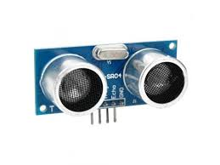
ESP32 | 1 | Microprocessor to control the system | 400 L.E | Electronics shop | 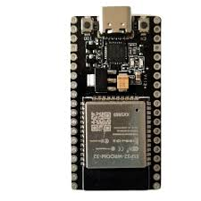
LEDs | 8 | Second method to announce that the road is full of cars | 4 L.E | Electronics shop | 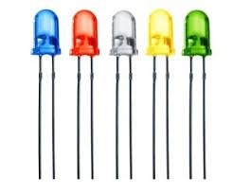
Resistors (220Ω) | 8 | To prevent the LEDs from burn out | 4 L.E | Electronics shop | 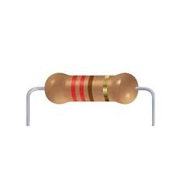
Wires (10-20cm) | 50 | To connect all components by each other | 50 L.E | Electronics shop | 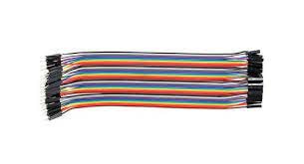
Ultrasonic sensor holders | 7 | To hold the sensor above certain distance | 105 L.E | Electronics shop | 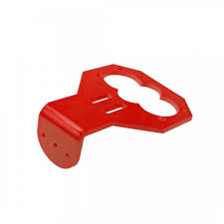
Bread Board | 1 | To arrange all used wires in the prototype | 100 L.E | Electronics shop | 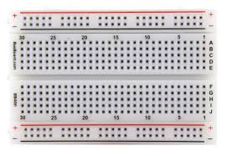
Lithium batteries | 3 | To power the whole prototype | 60 L.E for Each | Electronics shop | 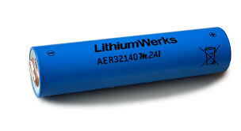
Batteries holders | 1 | To connect the batteries with the wires | 30 L.E | Electronics shop | 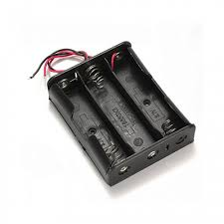
Micro cable | 1 | To connect the microprocessor by the laptop | 30 L.E | Electronics shop | 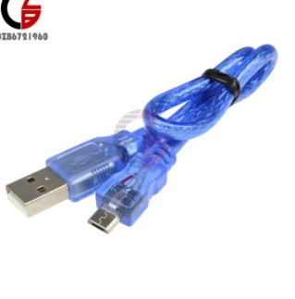
MDF (medium-density fibreboard) | 11 pieces | To make the shape of the street and | 70 L.E for each board | Carpentry store | 
Super glue | 1 | To stick the pieces by each other | 30 L.E | Stationary | 
Electrostatic tape | 1 | To connect the wires with each other | 15 L.E | Electronics store | 
Small cars | 10 | Used to test the prototype | 170 L.E | Toys store | 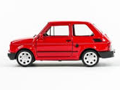
Total price:1503 L.E

Methods:
The prototype was built according to certain steps, which are:
The electrical parts:
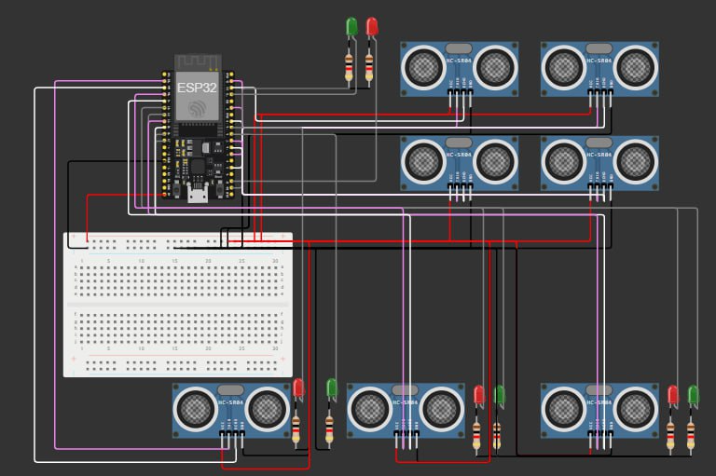
There is a room under the prototype which is like a home for all the components, each sensor on the street is connected to the ESP32 to gather data and make data base that the system takes the decision based on, the components are connected to a bread board to organize the wires, adding some green and red LEDs in front of each sub street to announce the street state as shown in figure 2, the system is powered by three lithium batteries as the system has the ability to work online and offline.
Figure 2
The electrical components at simulation lab
The website and technical part:
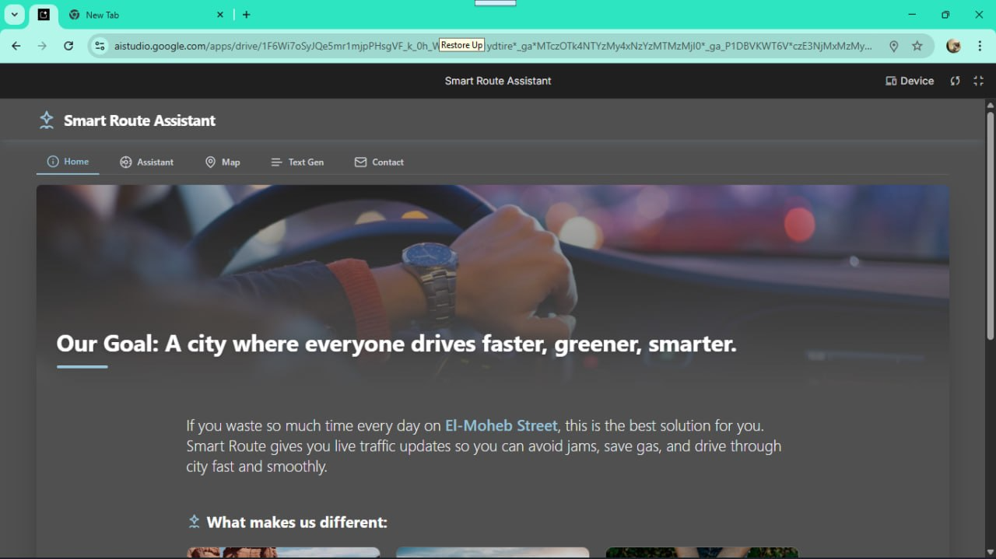
The main way to announce all the drivers by their routes and the street conditions is a website made by three main languages (HTML, CSS, Java Script) revealing many functions like: AI voice and text conversation, the map and your location on it, the website updated at the least possible time (according to the user network quality), and additional tab that talk about the prototype and where it’s installed showing some photos for the street as shown in figure 3.
Figure 3
The website interference
The street maquette:
Figure 4
3D model of the prototype
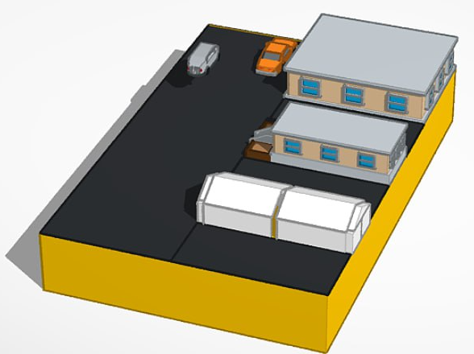
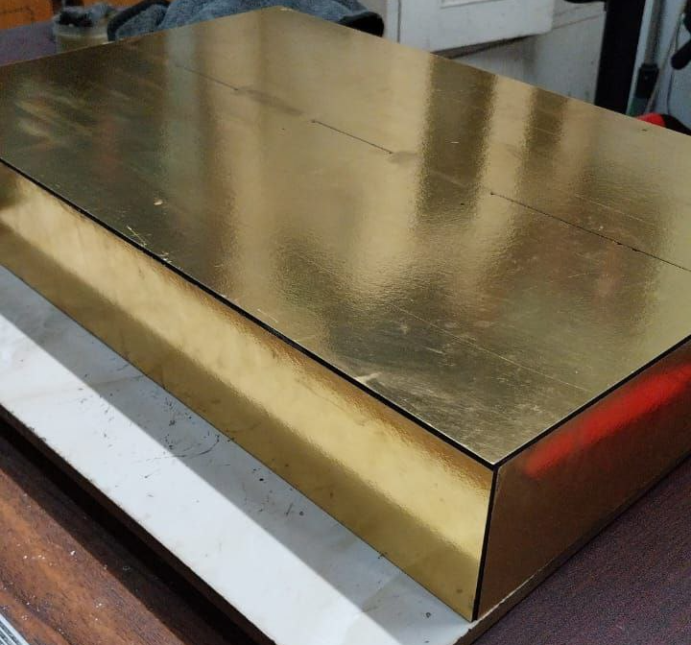
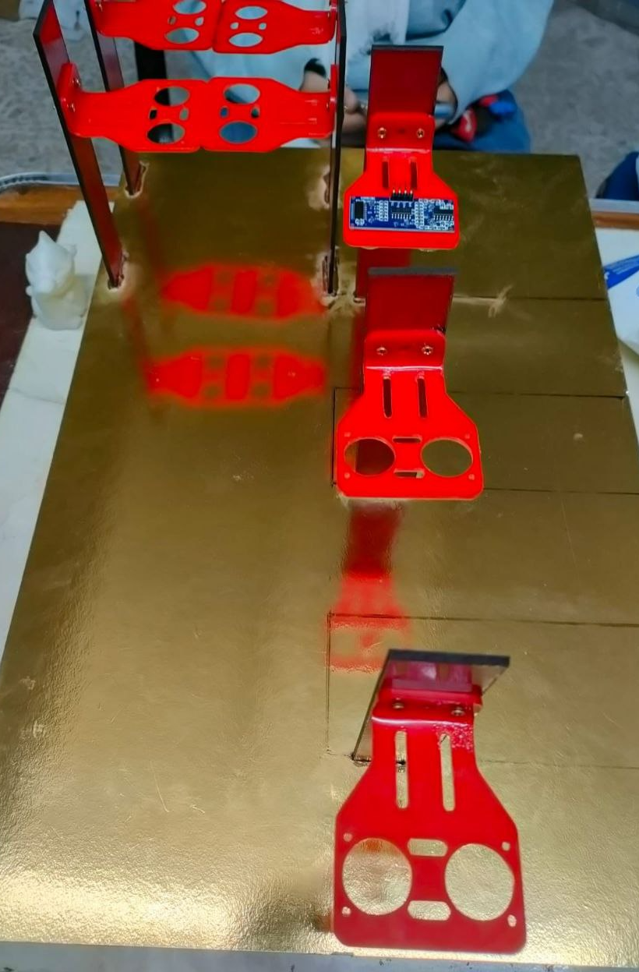
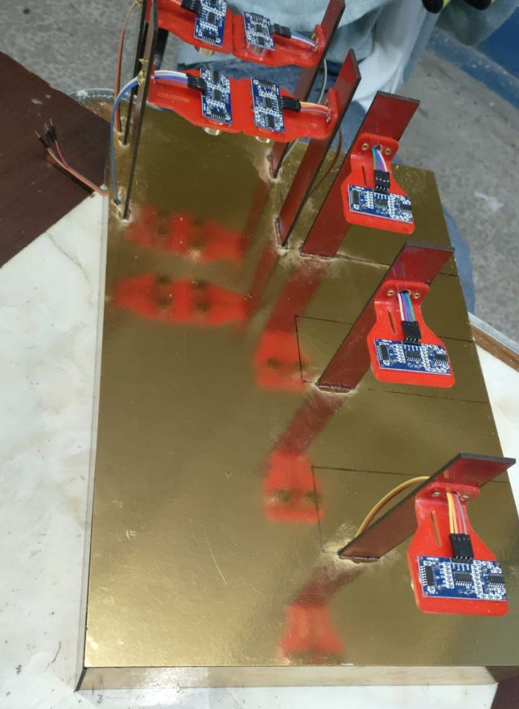

One board of the compressed carton was cut by CNC (Computer Numerical Control machine) into 11 pieces (1*(0.46×0.30), 2*(0.46×0.07), 2*(0.30×0.07), 7*(0.15×0.03)), the largest piece was cut to be the base of the prototype and is added to the next four pieces that in the same shape of the box as shown in figure 4, 5 to simulate the street and make a room for all the prototype electrical components and wires, the other 7 pieces were more likely a column as shown in figure 6 to attach the ultrasonic sensor on it as shown in figure 7, the base has a mini version of the street with the three sub streets attached to it and having some cars on it, all of these column had a small room to fit in and been glued inside made by a mini drill as shown in figure 8, after that a small LEDs (red and green) were attached to the beginning of every sub street and one pair installed in the beginning of the street to simulate the traffic signal in the cross section between Saeed and El-Moheb street.
Figure 5
The prototype base
Figure 6
The holders of ultrasonic before installing sensors
Figure 7
The holders of ultrasonic after installing sensors
Figure 8
The prototype base being cut by mini drill
Figure 9
The prototype after LEDs installed

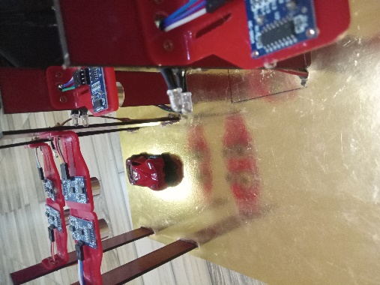

Safety precautions
- Fabrication Lab tools.
• Don't use any burst or ragged tools.
• using suitable tools for the job.
• The labels and uses of all the equipment must be known.
- Students' behavior
• If you are not sure, ask the Fab Lab teacher for help.
• Wear safety gear that is shown in the table in data collection
• Follow the rules the teacher sets when handling electrical items to avoid being shocked.
• Do not take any tools or materials from the labs; they are not yours.
- Electric Safety
• Keep the area dry, no water or wet stuff.
• Make sure wires are insulated.
• Dispose of waste that contains batteries, wires, and other parts, which can be dangerous to people and the environment.
• Use care for static electricity, which can ruin electronics.
• Always make sure to cut the power off before connecting to any time or change in the circuit.
• Make sure that the Arduino components have the right voltage to keep them safe or else they will have a problem or die.
- Environmental Issues
• Avoid working outside in hot weather to prevent damage to the Arduino parts.
• Perform tests in a safe place like a fabrication room, physics room, chemistry room, etc. To avoid accidents or property damage.
- Software Safety
• Save your Arduino program often and back up your Arduino code, or set it to run on its own to prevent losing your code.
• Always check your code and test it step by step before putting it on the Arduino, so your part doesn’t get broken.
- Physical, hardware, and fire safety
• Make sure your circuit does not send more current, power, or voltage to the parts than they can take.
• Always put your Arduino parts in a safe place, like a small box or eco-friendly bags.
Test Plan
Prototype testing to confirm the efficiency of the design. The prototype was tested to meet specific criteria:
- High accuracy
- Reduce trip time
- Low Time response
This was achieved by activating the prototype and transporting cars to the street, verifying ultrasonic sensors provide correct measurements and the LEDs respond accurately. Next, determination the quantity of system responses that are accurate, confirming 90% accuracy or above. Additionally, measuring trip time and time response using a stopwatch, recorded as 1.8 minutes or less for trip time, indicating a reduction by 70%. Time response was documented as 1 second or less.

Table 2
Test plane steps
Step no | Explanation
1 | Firstly (System Startup): Turn the system on and check if all parts work. These parts are the ultrasonic sensor and the eight LED lights.
2 | Secondly (Sensor Reliability and Validity Validation): determine time response, trip time (via stopwatch), and accuracy (using law of accuracy in percentage).
3 | Thirdly (Actual Data Check): Connect laptop to access live data. Verify that the color-coded LED system shows the busy street. System Sends accurate live alerts to website.

Date collection
Table 3
the tools that were used at the prototype
Tool | Usage | Image
Wax gun | A wax gun is important for crafting, repairs and precise application and bonding. | 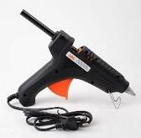
CNC (Computer Numerical Control machine) | To cut the MDF to make the road. | 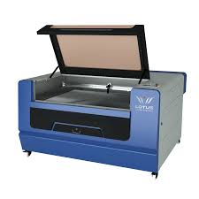
Adhesive tape | Adhesive tape is crucial for binding, repairing, and sealing items quickly and efficiently | 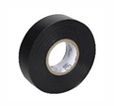
Soldering tool | A soldering tool is essential for joining electronic components, creating strong connections, and repairing circuits. | 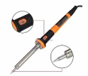
drill | To open some places at the road as to the ultrasonic and the ESP cable. | 
lighter | To bend the ultrasonic holders. | 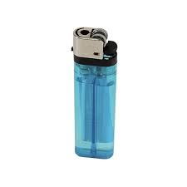
scissors | Used to cut some components as wires. | 

SAFETY PRECAUTIONS

Table 4
The safety instruments
Lab coat | It is necessary to stay warm and protected from the toxic elements | 
gloves | It is essential for protecting hands from the elements. Selecting gloves that are windproof and waterproof will offer additional protection when dealing with electric pieces. | 
Goggles | Wearing goggles will help to protect the eyes from the elements. Investing in goggles that are waterproof and scratch resistant will provide extra protections | 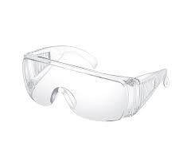

Results
The negative results:
- To use any AI the model should be trained on the values, the values are representing two conditions: if there’re cars or not, in this result the prototype AI unit wasn’t able to adapt on the training before the online test due to the shortage of data been inserted in the system and trained on them, this error made the prototype act with low accuracy as shown in table 4 and make wrong routes for users, turning on some LEDs without any reasons, and for sure increased the trip time.

- The detection of the ultrasonic which is in the main road as the distance of it at the code was more than the distance between the sensor and the ground so this sensor detection was always wrong as it detects car so that decreases the accuracy as it sends wrong reading of the sensor and turn on the sub streets LEDs resulting an increase in trip time as shown in table 4 as the driver see from the web site the main street is full and take another street.
Table 5
Negative results
n. trials | Time response | Accuracy | Trip time
1st negative trial | 1 seconds | 25 % | 420 s
2nd negative trail | 1 seconds | 75 % | 200 s

The positive result:
- As all the sensor calibrated, the AI training well, the code is written by the right method, all parts of prototype are calibrated correctly then the prototype was tested 3 times and collect the data for each design requirement as shown in table 3,4,5:

- Time response:

Table 6
First design requirement
Trials | Time response
1st | 0.65 s
2nd | 0.73 s
3rd | 0.59 s
Average | 0.66 s

- System accuracy:
Table 7
Second design requirement
Trials | Correct actions | Accuracy
1st | 12 | 100 %
2nd | 11 | 91.6 %
3rd | 11 | 91.6 %
Average | 11 | 94.4 %

- Trip time:

Table 8
Third design requirement
Trials | Time at prototype | At large scale | Trip time reduction %
1st | 0.39 s | 118.7 s | 71.7%
2nd | 0.32 s | 97.4 s | 76.8%
3rd | 0.36 s | 109.6 s | 73.9%
Average | 0.35 s | 108.55 s | 74.15%
Note. the first trip time at congestion is 420 second

Chapter IV (Evaluation, Reflection, Recommendations):

Analysis and construction
Egypt is suffering many challenges right now, one of the most focused on challenges is the urban congestion, as over than half of the humanity lives in the cities now and could be around 68% by 2050 which means more noise, congestion and fuel consumption due the fact that the city’s transportation now depends on the private cars and even the public buses, making the streets crowded more than the first time https://royalsocietypublishing.org/doi/epdf/10.1098/rsta.2024.0095 .
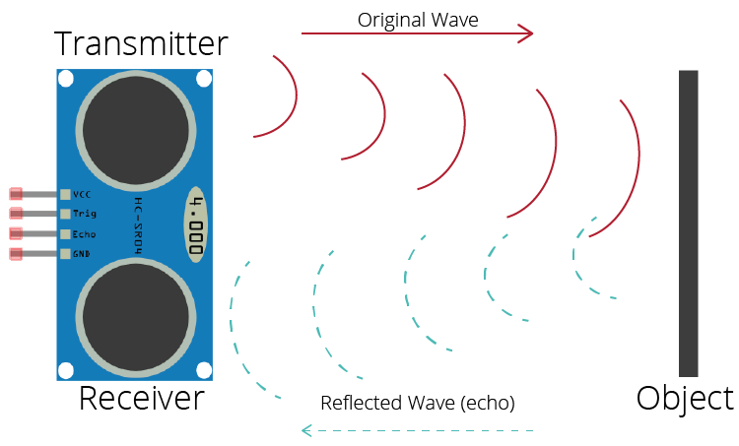
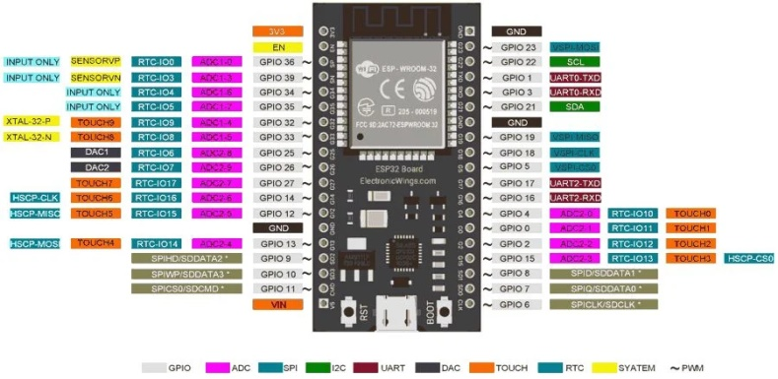
To solve the urban congestion a prototype that reduce the traffic congestion using AI and IOT to simulate the human being, the first part to talk about is the hardware system, HC-SR04 Ultrasonic, a sensor which transmits transverse mechanical waves with a frequency varies 20-40KHz knowing that every wave have its own characteristics as learnt in physics (PH.3.01) that formed by pressurized waves or cyclic sound stress with a frequency greater than the human hearing upper limit as shown in figure 10 using it to measure the distance between the street and the sound waves generator with maximum range 400cm and 2cm minimum (±0.3cm) https://randomnerdtutorials.com/esp32-hc-sr04-ultrasonic-arduino/. the change in the distance means that there's an object passing under the sensor using the formula U₂-U₁ (for both lanes in the street) as U₁ is the sensor in the beginning of the street and the U₂ is the another one behind U₁, there are seven from it, four in the main and one in every sub street , giving an interval [,] to tell if there's a car, in the other hand the prototype contains another component which is some signals similar to the traffic signs installed on the beginning of every sub street, but with only two colours: red and green, red colour for the condensed sub streets and the green for the empty ones, to gather the data through sensors and send it to the AI model a microprocessor was in use, specifically ESP32 for its many pinouts (38) as shown in figure 11 and the fact that it come with an on-chip 32-bit microprocessorr with integrated Wi-Fi, and BLE (Bluetooth low energy)
Figure 10
Ultrasonic way of work
Figure 11
ESP32 pinouts
features,https://www.electronicwings.com/esp32/introduction-to-esp32 the ESP role here is to gather the information and send it to the AI model via library called <HTTPClient.h>, a library connects to the server and start to send a request. If the input parameter contains “a Server Address”, DNS (Domain Name System) lookup will not be performed and just purely connect to the given IP address https://www.amebaiot.com/en/rtl8195-arduino-api-httpclient/ .
After the data been collected and sent to the AI, the AI analyse all numbers getting only the ones that it uses in the car detection, then display and update it to every user when needed or when any change happens simulating the hormonal cycle of the human as learnt in biology (BI.2.09), talking about the AI, it’s a .tsx (Typescript Execute) file merged to the website components, containing a React.js which is a library associated with the java script frontend of the website, used for component-based User Interface and manages the Virtual DOM tree with a reconciliation complexity of O(n) when n is number of input or input size https://www.w3schools.com/react/react_intro.asp , this logarithm means the time it takes grows linear with the input size, the, interface is connected with Google Gemini Live API which transmitting binary audio frames at a sample rate of 16KHz, every frame follows the Pulse-Code Modulation standard formed by discretized amplitude values with a 16 bit-depth greater than the quantization noise threshold known from communication learning outcome (PH.3.04) , this used to bridge the gap between the client-side audio content and the server-side Language Model with a maximum output of 48kbps and 1kbps minimum (±0.5kbps), the asynchronous JavaScript execution loop handles WebSocket events, letting the browser decode Base64 strings into audible waves within milliseconds. The error factor relative to API latency was calculated specifically addressing the network congestion effects on the round trip time (RTT ≈ 100ms), moving to the final website user interface, it was made using three coding languages: HTML learnt from computer science (CS.2.02), JavaScript, and CSS, optimistic UI updates was added to maintain fluidity and speed as the information update without the server confirms the action, also the system synchronizes geolocation coordinates and matches it with the map engine by taking the latitude and longitude from the website geolocation API and feeds them into the Google Maps view.
After finishing the construction of the project, the system been made on a small scale to make the tests required, so El-Moheb Street reduced into a smaller version by the factor 304 times smaller than the real street (140m:0.46m), the results gathered from testing the whole system, got three main results out as shown in figure 11, using the law of accuracy($\frac{n°}{nt}$×100) where n _{t} is the total number of the readings, and n$°$ is the value of the total right responses in addition to consider the error of the sensors readings and other components as learnt in the chemistry (CH.1.01), then use a timer to obtain the other design requirements: trip time, and time response, the first result was a bit confusing as one sensor from the system at the main street was reading that there’s a car under the sensor even when the street is empty, when the sensor checked and replaced, the results still get out with the same problem, so the code was the second verification step, when it reversed the pinout of this sensor was coded to obtain that the street is under it by 15 cm not only 10cm like the realty so it indicated the street as a car, this result obtained a very decrease in the values of the accuracy and a big confusion in the system which made the trip time increases by a big delay due to the “fake” congestion in the main street giving values of 25% for the accuracy, 180s for trip time, 1s for time response.
The second result obtained was much better with the accuracy of the sensors readings, but in the other hand the AI showed some differs in the actions it took making the drivers confused and pass other ways when it could only pass by the main street as usual, when the AI checked and been tested some readings when there’s no cars under the sensors or in the cut section between the sensors, the AI counted it as a car which is not real car, resulting in a 75% accuracy, 1s for time response, and 100.5s trip time, so the best solution was to train it a bit more, in the third test the readings at all gathered with no problem but even meet the challenge by a less trip time by 74.6%, accuracy around 94.4%, and time response 1 second, all the results gathered are shown in figure 12, 13, 14.
Figure 13
second design requirement graph
Figure 12
First design requirement graph
Figure 14
Third design requirement graph

Recommendation
Last of all, the project is over. Here are some suggested additions to improve this project and ensure its success in the future.
These ideas are as follows:
- Add Machine Learning Traffic Prediction: The system uses sensors to see traffic in real time. But using smart algorithms like LSTM (Long Short-Term memory) could be used to predict traffic before it happens.
- Use weather-proof sensors: heavy rain or dust can mess up ultrasonic sensors. Better weather-proof sensors like LIDAR (Light Detection and Ranging) or radar would do the job exactly as wanted.
- Use Multi-Lane Camera-Based Detection: AI cameras can tell what kind of vehicle is in each lane and count cars across lanes for more accuracy.
- Use solar panels instead of the lithium batteries to power up the system.
- Thermal imaging sensor as it detects vehicles at night and more accurate.

Learning outcomes
Table 9
Number | Subject/LO | Connection
1 | CS.2.02 | As using HTML and designing a web site at our prototype as making a website which sends to the driver and using HTML when devolving it.
2 | BI.2.09 | The positive and negative feedback systems present in the human reproductive system as the system is a feedback system to reduce the traffic congestion.
3 | PH.3.01 | The waves oscillation as the ultrasonic sends waves to determine the distance below it and determine if there are an object.
4 | PH.3.04 | The communication as the ground wave modulation where the ultrasonic sensor is sends ground waves to do its function.
5 | CH.1.01 | As we learned the law of accuracy and apply it on our project to calculate the system accuracy depending on the number of responses.
6 | CS.1.01 | Using sketch up app to make a 3D model of the road to explain the measurements and the details then it was easier to understood it.
7 | MA.1.04 | As the similarity between the shapes and make ratios between the dimensions and the area as the street we work on and the prototype road simulation and the ratio between the length of the real and prototype.
8 | BI.3.01 | Nervous system pathway is similar to IoT-system where sensory neurons represent sensors, CNS represent AI model and Motor neurons represent the respond which system will take.
9 | EN.3.02 | Improve our English knowledge and vocabulary to enhance the portfolio and poster efficiency as learning vocabulary about the AI and modern devices.
10 | ES.2.01 | As learned the water cycle as the system is a cycle of actions and responses and return to the main point until reduce the traffic congestion and return it if there are congestion.
11 | MA.1.02 | As learned the relation between the variables, making graphs and the types of the graphs then we use it while collecting the data and represent it in a graph as line at accuracy measure and column graph at the time response.
12 | PH.2.03 | As learned about the resistance role at the electric circuit as we use it to connect the LED and the wire to avoid burning out the components from the extra voltage.

List of resources in APA format

